- Data Warehousing is an important part of Data Engineering.
Data Engineering is a broader field, and Data Warehousing is one of its core components.

How are they related?
  - Data Engineering: Focuses on designing, building, and maintaining systems that collect, process, transform, and deliver data.
  - Data Warehousing: Focuses on storing structured, processed, and organized data so it can be used for analytics, reporting, and business intelligence.

Where does Data Warehousing fit in Data Engineering?
Data Engineering
Data Pipeline Development
Extract → Transform → Load (ETL/ELT)
Data Warehouse
Snowflake | BigQuery | Amazon Redshift
Analytics & Business Intelligence
Power BI | Tableau | Looker

Important Data Engineering skills
Area | Technologies
Programming | Python, SQL
Databases | PostgreSQL, MySQL
Data Warehousing | Snowflake, BigQuery, Redshift
ETL/ELT | dbt, Airflow
Big Data | Spark, Kafka
Cloud | AWS, Azure, GCP
Visualization | Power BI, Tableau

Real-world example
Imagine an e-commerce company like Amazon:
  - Customers place orders.
  - Data engineers collect order data from different systems.
  - They use Python and SQL to clean and transform the data.
  - They load the processed data into a data warehouse such as Snowflake.
  - Analysts use Power BI to generate sales reports.
The key takeaway: Data Warehousing is a subset of the broader Data Engineering ecosystem. Learning data warehousing is essential if you want to become a Data Engineer.

Data Lakes are also an important part of Data Engineering, just like Data Warehouses.
The main difference is how they store and manage data.

1. What is a Data Lake?
A Data Lake is a centralized storage system that stores large amounts of raw data in its original format.
It can store:
- Structured data (SQL tables, CSV files)
- Semi-structured data (JSON, XML, logs)
- Unstructured data (images, videos, audio, PDFs)
For example, an e-commerce company might store customer transactions, website logs, product images, and clickstream data in a Data Lake.
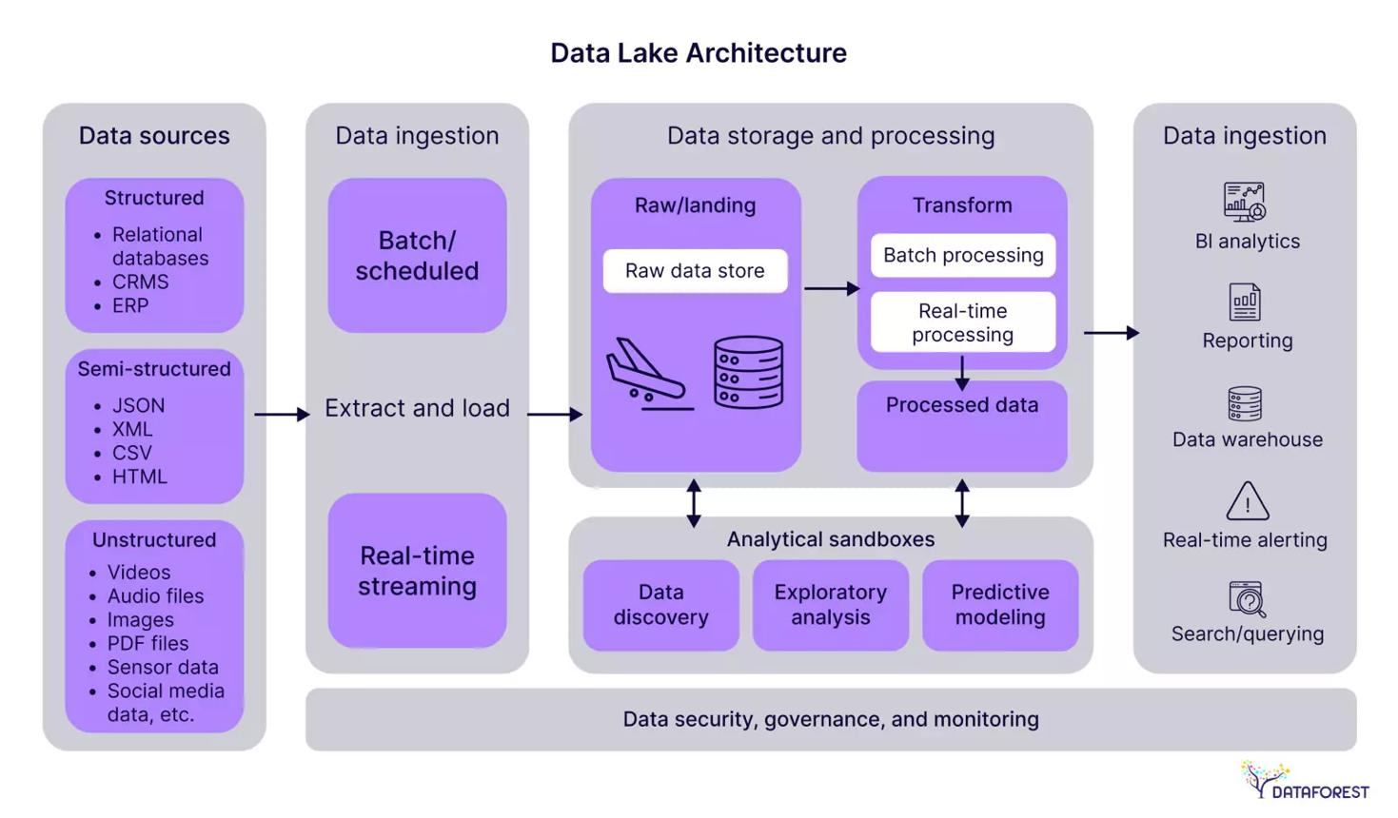

2. Data Lake vs Data Warehouse
Feature | Data Lake | Data Warehouse
Data | Raw data | Processed data
Format | Structured, semi-structured, unstructured | Mostly structured
Schema | Schema-on-read | Schema-on-write
Storage cost | Generally lower | Generally higher
Main purpose | Store and explore data | Analytics and reporting
Users | Data Engineers, Data Scientists | Data Analysts, BI Developers
Examples | Amazon S3, Azure Data Lake | Snowflake, BigQuery, Redshift

3. How Data Lakes fit into Data Engineering
Data Sources
Applications, databases, APIs, IoT
Data Lake
Stores raw data
Data Processing
Python, SQL, Apache Spark
Data Warehouse
Cleaned and structured data
Analytics & Reporting
Power BI, Tableau, Machine Learning

4. Popular Data Lake technologies

Amazon S3
Cloud object storage commonly used as a data lake.
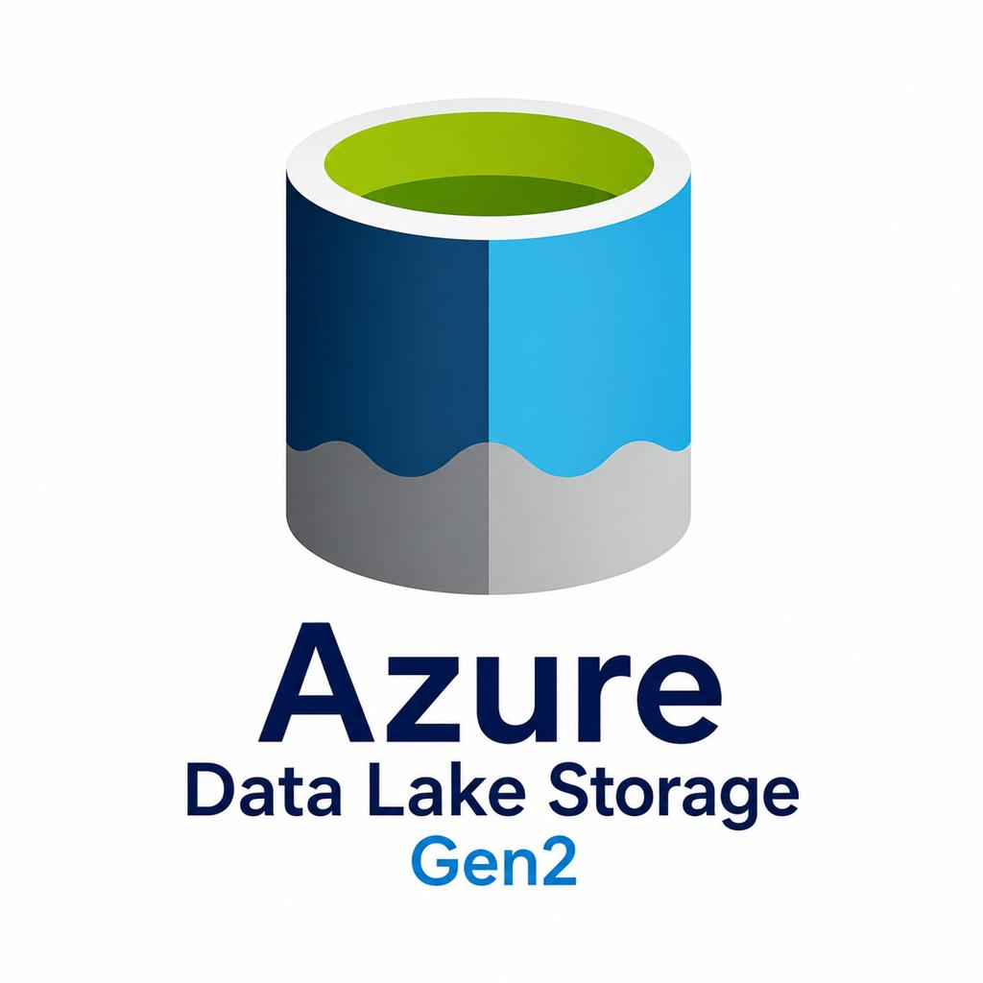
Azure Data Lake Storage
Microsoft's cloud-based data lake storage.

Google Cloud Storage
Google Cloud object storage for data lake architectures.
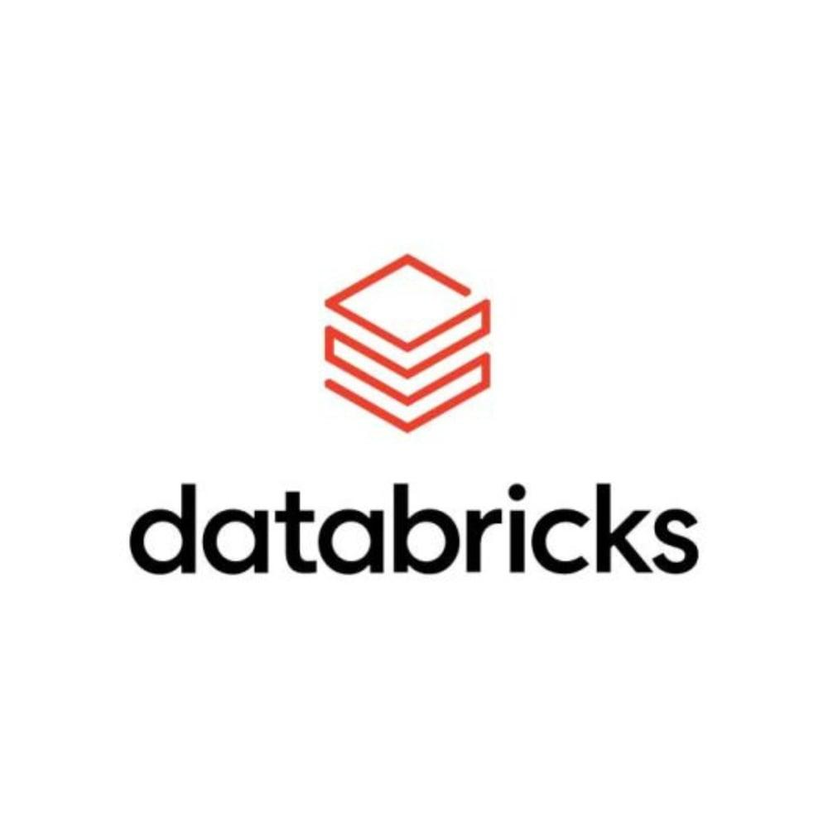
Databricks
Lakehouse platform for data engineering and analytics.

5. What should you learn as a Data Engineer?
I recommend learning in this order:
- SQL
- Python
- Database fundamentals
- ETL and ELT pipelines
- Data Warehousing
- Data Lakes
- Apache Spark
- Apache Airflow
- Cloud platforms (AWS/Azure/GCP)
- Databricks and Delta Lake
One important concept to understand: A modern architecture called a Data Lakehouse combines features of Data Lakes and Data Warehouses. Technologies like Delta Lake and Apache Iceberg help make this possible.

Let's understand Data Lake vs Data Warehouse vs Data Lakehouse with a real-world example. This is an important concept for becoming a Data Engineer.

1. Imagine an e-commerce company
Suppose you work as a Data Engineer at an e-commerce company like Amazon.
Every day, the company generates different types of data:
- Customer information
- Product details
- Order transactions
- Payment information
- Website click logs
- Product images
- Customer reviews
The company needs to store, process, and analyze all this data.
This is where Data Lakes, Data Warehouses, and Data Lakehouses come into the picture.

2. Data Lake
Raw data storage
A Data Lake stores all types of data in its original format.
Example:
An e-commerce company receives:
- Orders in CSV format.
- Customer data in JSON format.
- Website logs in text format.
- Product images in JPEG format.
All these files can be stored in a Data Lake.
Popular technologies:
- Amazon S3
- Azure Data Lake Storage
- Google Cloud Storage
Real-world use: Store huge amounts of raw data for future processing, analytics, and machine learning.

3. Data Warehouse
Processed data storage
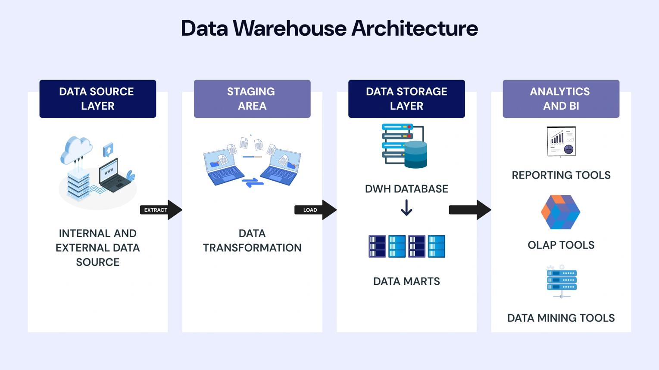
A Data Warehouse stores cleaned, transformed, and organized data.
For example, the Data Engineer takes raw order data from the Data Lake and:
- Removes duplicate records.
- Handles missing values.
- Standardizes dates and currencies.
- Calculates total sales.
- Organizes the data into structured tables.
Example:
Order ID | Customer | Amount
101 | Rahul | ₹2,000
102 | Amit | ₹3,500
103 | Priya | ₹1,500
Business analysts can now use this data to create reports.
Popular technologies:
- Snowflake
- Amazon Redshift
- Google BigQuery
- Azure Synapse Analytics
Real-world use: Business intelligence, dashboards, reporting, and SQL analytics.

4. Data Lakehouse
Modern architecture
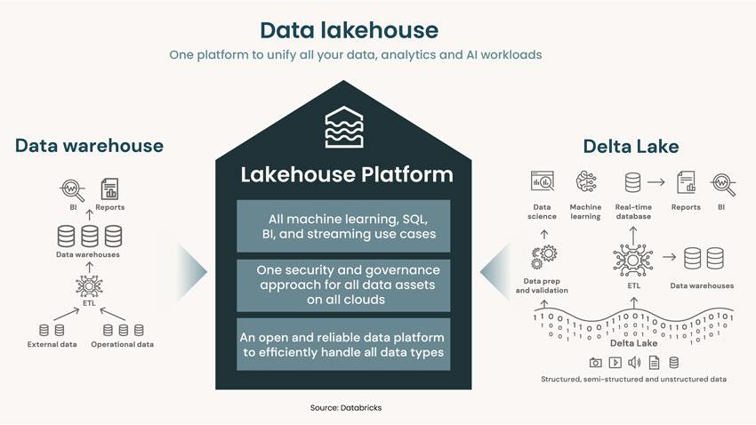
A Data Lakehouse combines the advantages of Data Lakes and Data Warehouses.
It provides:
- Low-cost, flexible storage like a Data Lake.
- Structured tables and reliable data management like a Data Warehouse.
- Support for SQL analytics and machine learning.
- Features such as transactions and schema enforcement.
For example:
An e-commerce company stores raw data in cloud object storage and uses a Lakehouse table format to manage that data reliably.
Popular technologies:
- Databricks
- Delta Lake
- Apache Iceberg
- Apache Hudi
Real-world use: Modern data platforms where data engineering, analytics, and machine learning work on a shared data foundation.

5. Comparison: All three together
Feature | Data Lake | Data Warehouse | Data Lakehouse
Data | Raw | Processed | Raw and processed
Storage | Object storage | Warehouse storage | Usually object storage
SQL analytics | Possible | Excellent | Excellent
Machine learning | Excellent | Supported | Excellent
Data management | Varies | Strong | Strong
Flexibility | High | More structured | High

6. How they fit into a Data Engineering project
Here is a simplified architecture you should understand as a Data Engineer.

End-to-end Data Engineering Pipeline
1. Data Sources
MySQL, APIs, CSV, applications
2. Data Ingestion
Apache Kafka, Airflow, Python
3. Data Lake
Amazon S3 / Azure Data Lake
Raw data
4. Data Processing
Python, SQL, Apache Spark, dbt
5. Data Warehouse / Lakehouse
Snowflake, BigQuery, Databricks
Analytics-ready data
6. Data Consumption
Power BI, Tableau, Machine Learning

Data Lake Architecture
A Data Lake Architecture is the design of a system that collects, stores, processes, and manages large amounts of data in its raw and processed formats.
As a Data Engineer, you should understand how data moves from its source into a Data Lake and eventually becomes useful for analytics and machine learning.

1. Overall Data Lake Architecture
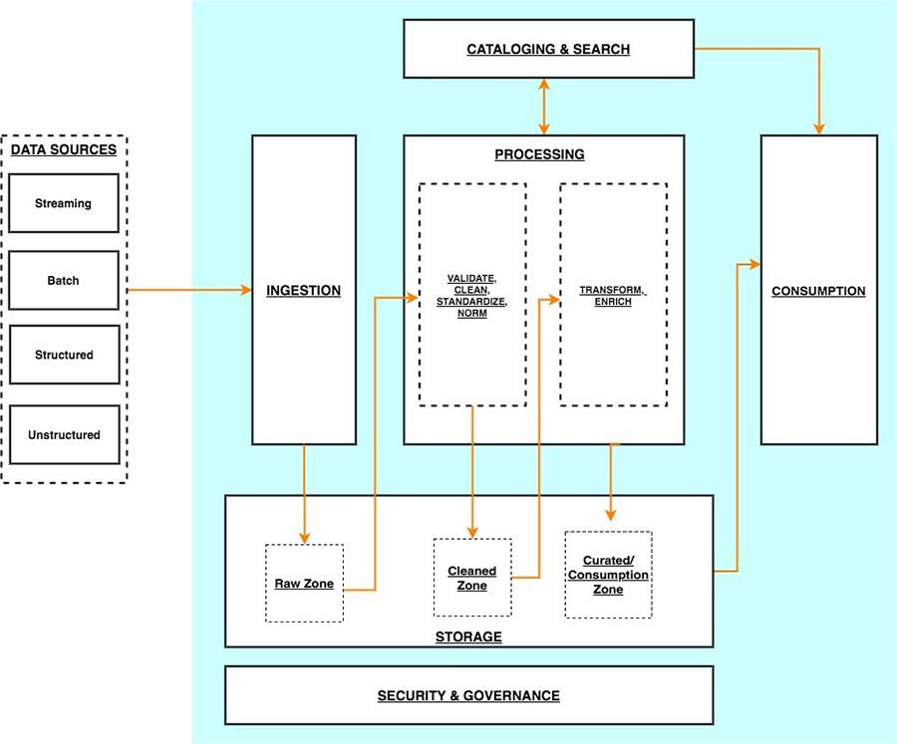
A typical Data Lake has six major layers:
1. Data Sources
MySQL, PostgreSQL, APIs, CSV, JSON, IoT
2. Data Ingestion Layer
Kafka, Python, AWS DMS, Airflow
3. Data Storage Layer
Amazon S3, Azure Data Lake, Google Cloud Storage
4. Data Processing Layer
Apache Spark, Python, Databricks
5. Data Catalog & Governance
AWS Glue Catalog, permissions, metadata, data quality
6. Data Consumption Layer
Athena, Power BI, Tableau, Machine Learning
Let's understand each layer.

2. Data Sources Layer
This is where data originates.
For example, an e-commerce company collects:
Source | Data
MySQL | Customer details
PostgreSQL | Order details
REST APIs | Payment information
Website | Customer activity logs
CSV files | Product information
IoT devices | Sensor data
Data can arrive in different formats:
- Structured: SQL tables
- Semi-structured: JSON, XML
- Unstructured: Images, videos, PDFs

3. Data Ingestion Layer
This layer moves data from different sources into the Data Lake.
There are two major ingestion methods:
A. Batch ingestion
Data is collected at scheduled intervals.
Example:
- Every hour
- Every day
- Every week
Tools:
- Python
- Apache Airflow
- AWS Glue
- AWS DMS
B. Streaming ingestion
Data is collected continuously or in near real time.
Example:
- Customer places an order.
- Payment is completed.
- Website activity is recorded.
Tools:
- Apache Kafka
- Amazon Kinesis

4. Data Storage Layer
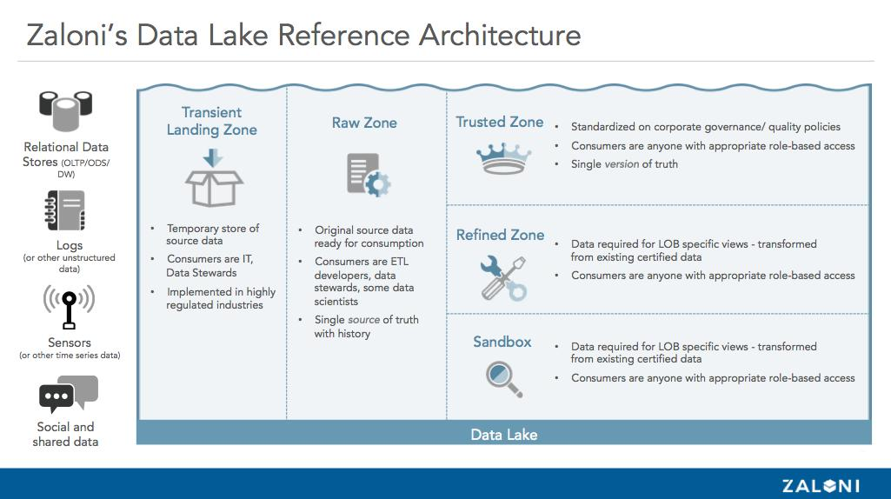
This is one of the most important parts of Data Lake Architecture.
A common design uses three storage zones.
Zone | Purpose | Example
Bronze | Raw data | Original JSON and CSV
Silver | Cleaned data | Deduplicated and validated records
Gold | Business-ready data | Sales summaries and customer analytics
This is commonly called the Medallion Architecture.
Example using Amazon S3:
text
ecommerce-data-lake/
│
├── bronze/
│ ├── customers/
│ ├── orders/
│ └── payments/
│
├── silver/
│ ├── customers/
│ ├── orders/
│ └── payments/
│
└── gold/
├── daily_sales/
├── customer_summary/
└── revenue_report/
Note: Bronze, Silver, and Gold are logical data layers, not mandatory physical storage types.

5. Data Processing Layer
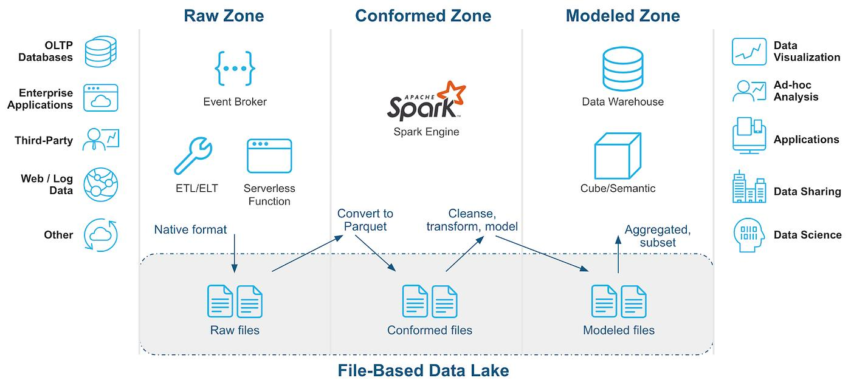
Here, raw data is transformed into useful data.
For example:
Suppose the Bronze layer contains:
Order ID | Customer | Amount
101 | Rahul | 2000
101 | Rahul | 2000
102 | Amit | 3500
The Data Engineer processes it:
- Remove duplicate records.
- Handle missing values.
- Validate records.
- Apply business rules.
- Convert data into Parquet format.
- Store the output in the Silver layer.
Popular technologies:
- Apache Spark
- PySpark
- Databricks
- Python
- dbt (for supported SQL transformation workflows)

6. Data Catalog and Governance Layer
This layer helps manage and understand the data.
It handles:
- Metadata management
- Schema management
- Data discovery
- Access control
- Data lineage
- Data quality
Popular tools:
- AWS Glue Data Catalog
- Microsoft Purview
- Unity Catalog
- Apache Atlas
For example, if an analyst wants to find the customer table, the Data Catalog helps them discover its location, schema, and description.

7. Data Consumption Layer
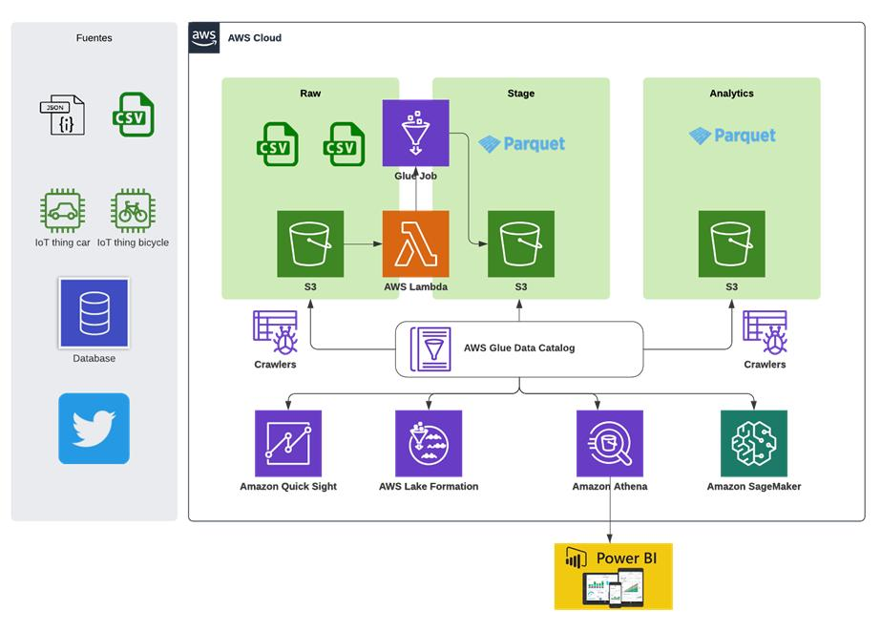
This is where users access the processed data.
Examples:
- Data Analysts create dashboards.
- Data Scientists build machine learning models.
- Business teams analyze sales.
- Data Engineers provide datasets to downstream systems.
Popular tools:
- Amazon Athena
- Amazon Redshift
- Power BI
- Tableau
- Databricks SQL

8. Real-world example: AWS Data Lake Architecture
Let's connect everything using AWS technologies.
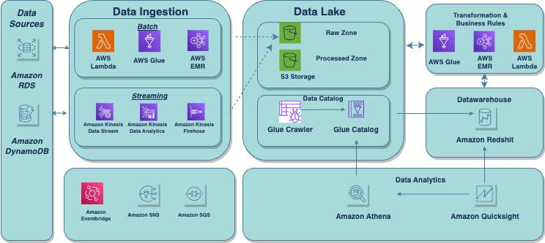
Architecture Layer | AWS Technology
Data Sources | RDS, MySQL, APIs
Data Ingestion | AWS DMS, Kinesis
Storage | Amazon S3
Processing | AWS Glue, EMR
Catalog | AWS Glue Data Catalog
Query | Amazon Athena
Analytics | Amazon Redshift, QuickSight
Security | IAM, Lake Formation

Example workflow
Imagine a customer places an order.
- Order information is generated in MySQL.
- AWS DMS replicates the data into Amazon S3.
- Raw data gets stored in the Bronze layer.
- AWS Glue and PySpark clean the data.
- Cleaned data gets stored in the Silver layer.
- Business-level aggregations are created in the Gold layer.
- Amazon Athena queries the Gold data.
- Power BI displays sales reports.

9. What should you learn practically?
If you want to become a Data Engineer, I recommend learning this architecture hands-on.
Learning order | Skill
1 | SQL and Python
2 | AWS S3
3 | Data ingestion using Python
4 | AWS Glue
5 | PySpark
6 | Bronze, Silver, Gold architecture
7 | AWS Glue Data Catalog
8 | Amazon Athena
9 | Airflow
10 | Data Lake security and governance

Data Lake: Use Cases and Challenges
Data Lakes are widely used in modern Data Engineering because organizations generate massive amounts of data from applications, databases, websites, IoT devices, and other systems.
Let's understand where Data Lakes are used in real-world companies, why they use them, and what challenges Data Engineers face.

1. Real-world use cases of Data Lakes

1. E-commerce
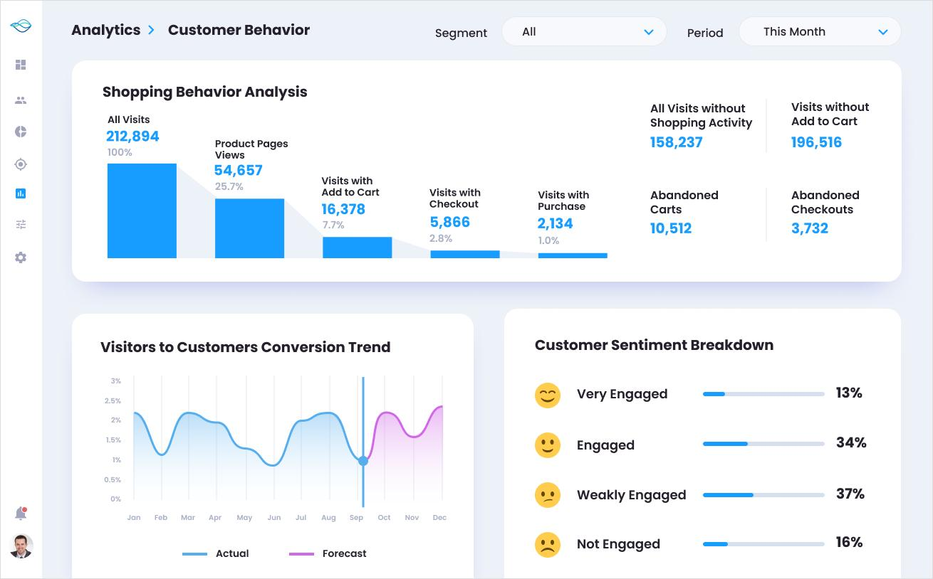
Companies like Amazon and Flipkart generate huge amounts of data.
Data collected:
- Customer information
- Order history
- Payment transactions
- Product details
- Website clickstream data
- Product reviews and images
How Data Lakes help:
- Store customer and transaction data.
- Analyze customer purchasing behavior.
- Recommend products.
- Identify customer buying patterns.
- Predict future sales.
Example: When a customer searches for a mobile phone, the company analyzes previous customer behavior to recommend similar products.

2. Banking and Financial Services
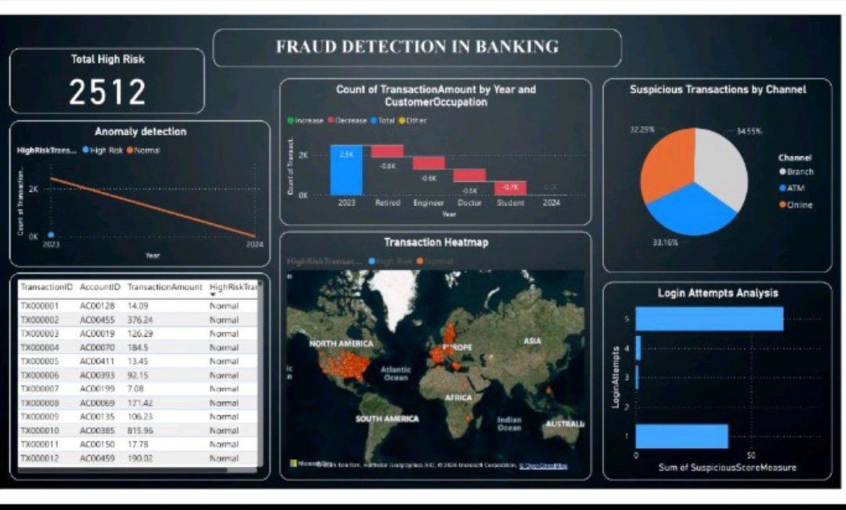
Banks generate enormous amounts of transactional data.
Data collected:
- ATM transactions
- Credit card transactions
- Online banking activity
- Customer information
- Loan applications
How Data Lakes help:
- Detect fraudulent transactions.
- Analyze spending patterns.
- Identify suspicious activities.
- Support risk management.
- Build machine learning models.
Example: If a credit card is suddenly used for unusual transactions in different locations, a fraud detection system can flag the activity.

3. Healthcare

Hospitals and healthcare organizations generate different types of data.
Data collected:
- Patient records
- Medical reports
- X-ray images
- MRI scans
- Laboratory results
- Medical equipment data
How Data Lakes help:
- Store medical records and images.
- Analyze patient trends.
- Support medical research.
- Build predictive healthcare models.

4. Telecommunications
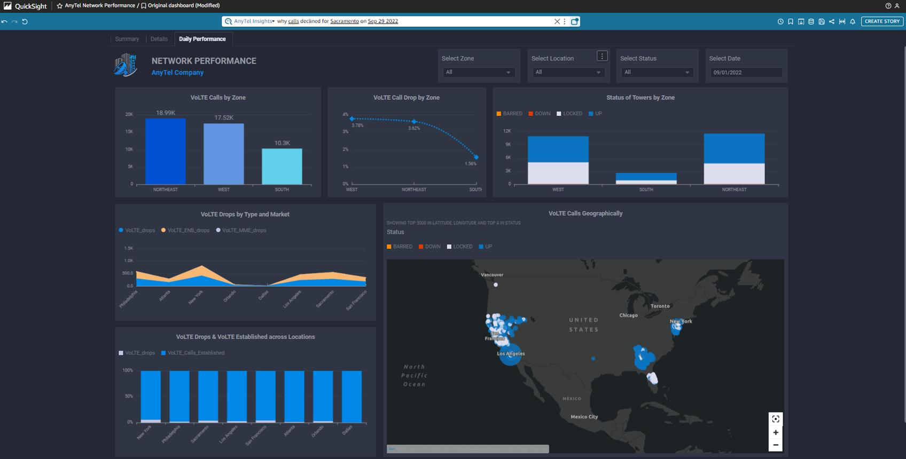
Telecom companies generate huge amounts of network data.
Data collected:
- Call records
- Internet usage
- Network logs
- Location and network performance data
- Customer complaints
How Data Lakes help:
- Monitor network performance.
- Detect network failures.
- Predict network congestion.
- Analyze customer behavior.
- Reduce customer churn.

5. Manufacturing

Factories use sensors and IoT devices to monitor machines.
Data collected:
- Temperature readings
- Machine vibration
- Production information
- Equipment performance
- Maintenance logs
How Data Lakes help:
- Predict equipment failures.
- Monitor production quality.
- Reduce machine downtime.
- Improve operational efficiency.
Example: Sensor readings can help predict when a machine is likely to fail, allowing maintenance before the breakdown.

2. Summary of Data Lake use cases
Industry | Main use case
E-commerce | Customer recommendations
Banking | Fraud detection
Healthcare | Medical research
Telecom | Network monitoring
Manufacturing | Predictive maintenance
Retail | Sales forecasting
Transportation | Route optimization
Media | Content recommendations

3. Challenges in Data Lake Architecture
Although Data Lakes provide many benefits, they also introduce challenges.
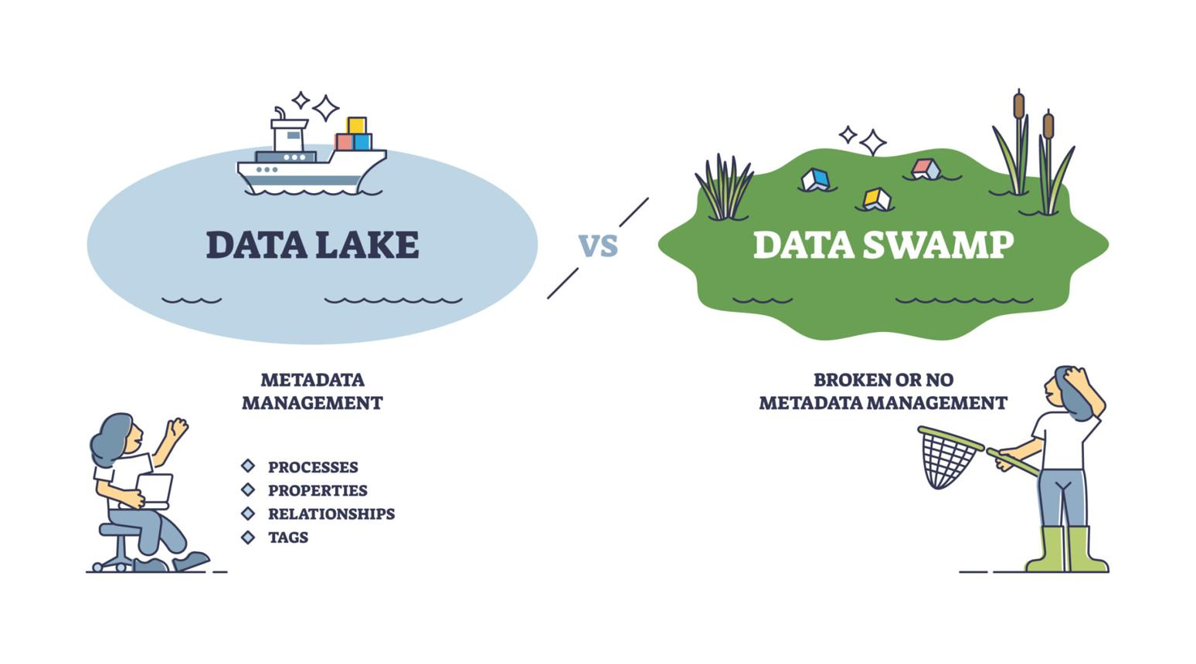
Let's understand the important challenges from a Data Engineer's perspective.

Challenge 1: Data Quality
Problem: Data comes from multiple sources and may contain:
- Duplicate records
- Missing values
- Incorrect data types
- Invalid records
- Inconsistent formats
Example:
Customer ID | Name | Age
101 | Rahul | 25
101 | Rahul | 25
102 | Amit | NULL
103 | Priya | -10
The data needs validation and cleaning.
Solutions:
- Use PySpark for data cleaning.
- Implement data validation rules.
- Remove duplicates.
- Handle missing values.
- Use data quality frameworks such as Great Expectations.

Challenge 2: Data Security
Problem: Data Lakes may contain sensitive information such as:
- Customer details
- Banking information
- Medical records
- Personal information
Unauthorized access can expose confidential data.
Solutions:
- Role-based access control.
- Encryption at rest and in transit.
- IAM policies.
- Data masking.
- Audit logging.
AWS technologies include IAM, KMS, and Lake Formation.

Challenge 3: Data Governance
Problem: When millions of files are stored in a Data Lake, it becomes difficult to understand:
- What data is available?
- Where is the data stored?
- Who owns the data?
- What does each column represent?
- Who can access it?
This can turn a Data Lake into a Data Swamp.
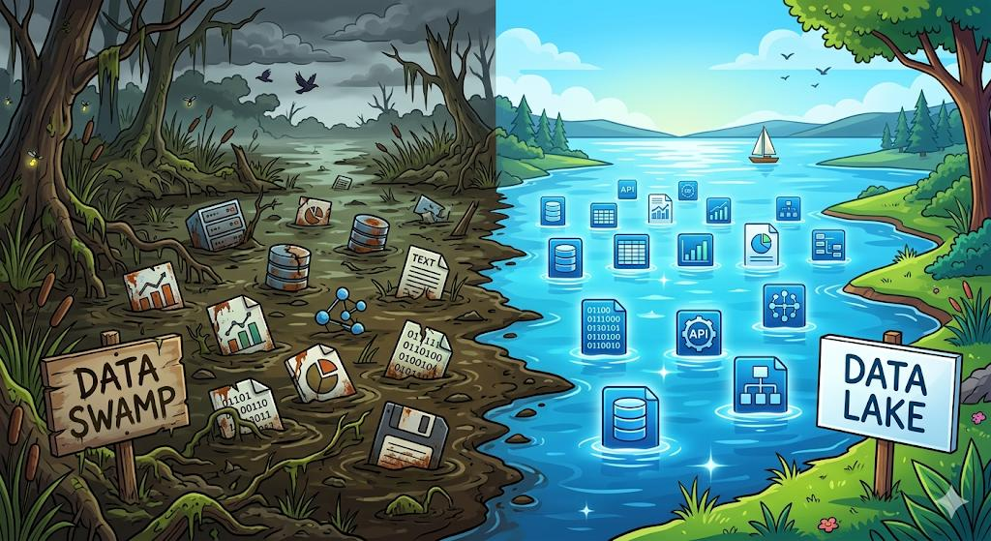
A Data Swamp is a poorly managed Data Lake containing disorganized, undocumented, or unreliable data.
Solutions:
- Maintain a data catalog.
- Document datasets and schemas.
- Track data lineage.
- Implement ownership and access policies.
- Use AWS Glue Data Catalog or Unity Catalog.

Challenge 4: Performance and Query Optimization
Problem: Querying millions or billions of records can be slow, especially when data is stored inefficiently.
For example, imagine querying 5 TB of CSV files to calculate daily sales.
Solutions:
- Use Parquet or ORC instead of inefficient text formats.
- Partition data appropriately.
- Use column pruning.
- Optimize file sizes.
- Use query engines such as Athena or Spark.
Example folder structure:
text
sales/
year=2026/
month=01/
month=02/
month=03/
If you query January 2026 data, partition pruning can help avoid scanning unrelated months.

Challenge 5: Managing Storage Costs
Problem: Data Lakes store enormous amounts of data. Storage and processing costs can increase over time.
For example:
- Old transaction data may not be frequently accessed.
- Duplicate files consume unnecessary storage.
- Large Spark jobs consume computing resources.
Solutions:
- Use storage lifecycle policies.
- Move older data to cheaper storage tiers.
- Remove unnecessary duplicate files.
- Compress data.
- Monitor compute and storage costs.
For AWS, S3 lifecycle policies and storage classes can help.

Challenge 6: Schema Evolution
Problem: Data formats and structures can change over time.
For example, an original customer dataset:
json
{
"customer_id": 101,
"name": "Rahul"
}
Later, the source application adds a new field:
json
{
"customer_id": 101,
"name": "Rahul",
"email": "rahul@example.com"
}
Your data pipeline must handle this change without breaking.
Solutions:
- Implement schema validation.
- Handle new and optional columns.
- Use schema evolution features in Delta Lake or Apache Iceberg.
- Monitor upstream data changes.

Challenge 7: Pipeline Failures
Problem: Data ingestion and processing jobs may fail because of:
- Network failures
- API errors
- Invalid input files
- Memory issues
- Application crashes
Solutions:
- Implement retries.
- Maintain error logs.
- Use monitoring and alerts.
- Design idempotent pipelines.
- Implement checkpointing where appropriate.
Tools: Apache Airflow, AWS CloudWatch, and Databricks monitoring.

4. Data Lake challenges and solutions: Quick revision
Challenge | Solution | Example technology
Data quality | Validation and cleaning | Great Expectations
Security | Encryption and access control | AWS IAM, KMS
Governance | Metadata and lineage | AWS Glue
Performance | Partitioning and Parquet | Spark, Athena
Storage cost | Lifecycle management | Amazon S3
Schema evolution | Schema management | Delta Lake, Iceberg
Pipeline failures | Monitoring and retries | Airflow, CloudWatch

5. What does a Data Engineer actually do?
Imagine you are working as a Data Engineer for an e-commerce company.
Your responsibilities might look like this:

Real-world Data Engineer responsibilities
- Ingest data
Extract customer and order information from MySQL and APIs.
Python, AWS DMS
- Store raw data
Load incoming data into Amazon S3 Bronze.
Amazon S3
- Clean data
Remove duplicates, validate records, and handle missing values.
Python, PySpark
- Optimize data
Convert data into Parquet and partition it by date.
Apache Spark
- Manage metadata
Register tables and manage schemas.
AWS Glue Data Catalog
- Monitor pipelines
Detect failed jobs and implement retries.
Apache Airflow, CloudWatch
- Provide analytics-ready data
Make cleaned data available to analysts and reporting systems.
Amazon Athena, Power BI

6. Interview questions you should prepare
Here are some common Data Engineering interview questions related to Data Lakes:
- What is a Data Lake?
- What is the difference between a Data Lake and a Data Warehouse?
- What is a Data Swamp?
- What are Bronze, Silver, and Gold layers?
- What is schema evolution?
- How do you optimize queries in a Data Lake?
- How do you handle duplicate records?
- How do you secure sensitive data in a Data Lake?
- What is partitioning, and why is it important?
- What happens when an ingestion pipeline fails?

7. Test your practical understanding
Data Lake interview practice
0/4 answered
1. A Data Lake contains millions of undocumented and unorganized files. What is this condition called?
Data Warehouse
Data Swamp
Data Mart
2. You have 5 TB of CSV files and queries are slow. What is a useful optimization?
Convert to Parquet and partition appropriately
Store more duplicate files
Remove the data catalog
3. Your source system adds a new column. Which concept helps your pipeline handle this change?
Data masking
Schema evolution
Data compression
4. Which practice helps protect confidential customer data?
Public bucket access
Encryption and access control
Disabling audit logs

